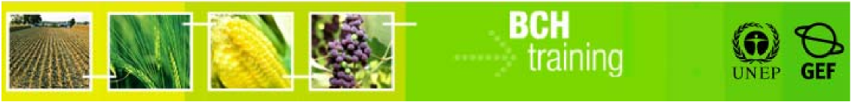

**A User’s Guide to the Central Portal of the Biosafety Clearing-House**

“Registering Information in the BCH Central Portal”

July 2012

Version: 5.0

**MANUAL OUTLINE**

1. Introduction to the Manual 4

2. The BCH Management Centre 5

3. Sign in to the Biosafety Clearing-House 5

3.1. The “Sign in” mechanism 6

3.2. The “Sign up for a BCH account” links. 6

3.2.1. Choosing a password 7

3.3. The “Forgot your password?” link 8

4. The Management Centre main page 9

4.1. Register a new record 10

4.1.1. Categories of documents: national and reference records 12

4.1.2. Common Formats 14

4.1.2.1. Offline Common Formats 14

4.1.2.2. Online Common Formats 16

4.1.3. Using the online registration forms 17

4.1.3.1. Mandatory fields 20

4.1.3.2. Language selection 20

4.1.3.3. References to other records 22

4.1.3.4. Fields displayed according to answers provided previously. 24

4.1.3.5. Additional Information fields 26

4.1.3.6. Timeframes for confirming or updating document content. 26

4.1.4. Reviewing and saving a record 29

4.1.5. Validation 31

4.2. Edit a published record 33

4.3. Edit a draft record 33

4.4. Validate pending records 34

4.5. Record Status 35

4.6. National Records Completeness 36

4.7. Personal Account 37

4.7.1. My Profile 38

4.7.2. My Subscriptions 38

4.7.3. Password change 39

4.7.4. Sign out 39

4.8. Administration (BCH - National Focal Points only) 40

4.8.1. National Authorized Users 40

5. Completing offline Common Formats 44

6. Training Site 48

**Reproduction**  
  
The content of this publication may be reproduced in whole or in part and in any form for educational or non-profit purposes without special permission from the copyright holder, provided acknowledgment of the source is made. United Nations Environment Programme (UNEP) would appreciate receiving a copy of any publication that uses this publication as a source. No use of this publication may be made for resale or any other commercial purpose whatsoever without prior permission in writing from UNEP. The use of information from this publication concerning proprietary products for publicity or advertising is not permitted.

**Disclaimers**The content and views expressed in this publication do not necessarily reflect the views or policies of the contributory organizations or the UNEP and neither do they imply any endorsement. The designations employed and the presentation of material in this publication do not imply the expression of any opinion whatsoever on the part of UNEP concerning the legal status of any country, territory or city or its authorities, or concerning the delimitation of its frontiers and boundaries. Mention of a commercial company or product in this publication does not imply the endorsement of UNEP.

# Introduction to the Manual

In this manual you will learn about the creation and management of information in the Biosafety Clearing-House (BCH) through its Management Centre. It explains:

* What the BCH Management Centre is and how to access it
* How to create and manage information in the BCH
* How to manage your personal profile
* How to manage National Authorized Users
* How to use BCH Training Site

***Context***

The UNEP-GEF Project for Capacity Building for Effective Participation in the Biosafety Clearing-House (BCH-I), in collaboration with the Secretariat of the Convention on Biological Diversity (SCBD), prepared a modular training package aimed at providing a practical “how-to” guide for countries to assist them in learning, understanding, using, and setting up national access to the BCH. The training package was later updated within the UNEP-GEF Project for Continued Enhancement of Capacity Building for Effective Participation in the BCH (BCH-II). It was designed to be flexible and is tailored to meet the diverse needs of different countries, allowing them to select those tools that are most useful to their situation, needs and priorities. The training package is divided into several manuals, each addressing one element of the BCH.

***Audience***

This manual is designed to provide guidance to BCH users who create and manage information in the BCH. It was developed for a non-technical audience with little or no knowledge of either the Cartagena Protocol or the BCH but who need to register information, access and manage information or set-up the IT-related components of the BCH.

***Purpose***

This manual demonstrates the process of registering information online directly in the BCH Central Portal through the Management Centre of the BCH.

BCH users with limited internet access may also register information offline by completing the offline common formats and submitting them, duly signed, to the Secretariat.

**© UNEP 2004-2012 all rights reserved**

# The BCH Management Centre

The Management Centre is a tool that enables users to create and manage information in the BCH. Access is restricted to BCH users with a registered BCH account.

Access to the “Registering Information” section of the BCH is available from the green horizontal navigation bar which appears on every page of the BCH Central Portal and also from the “Sign In” link in the upper right corner.

(Figure 1)

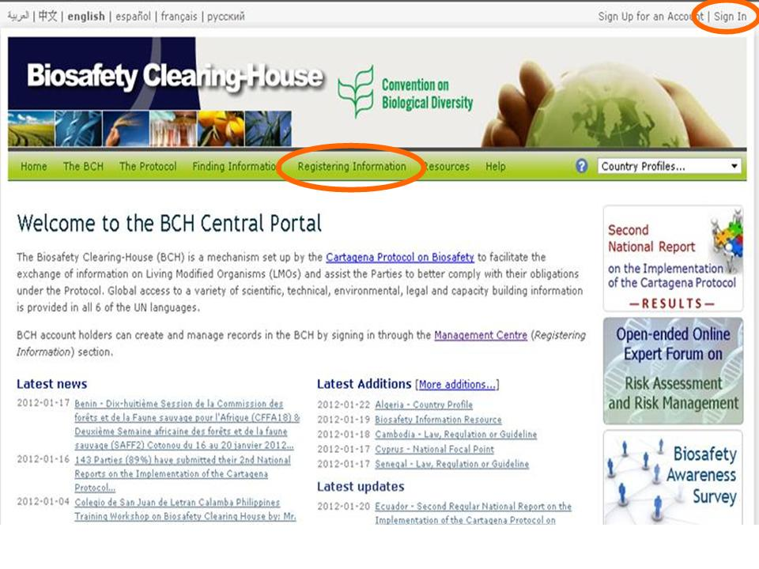

Figure 1

Any user can search the BCH databases at http://bch.cbd.int/ without a registered BCH account.

Registering a BCH account is only necessary if the user:

* Needs to submit information to the BCH;
* Would like to receive notifications by Email; or
* Would like to participate in the online forums and/or other interactive events organized through the BCH

# Sign in to the Biosafety Clearing-House

When clicked on the “Registering information” or “Sign in” link, you are redirected to the “Sign in to the Biosafety Clearing-House” page, which has the following main components:

1. The “Sign in” mechanism, with the **Remember me** checkbox;
2. The **Sign up for an Account** and **Sign Up for a BCH Account** links; and
3. The **Forgot your Password?** link.

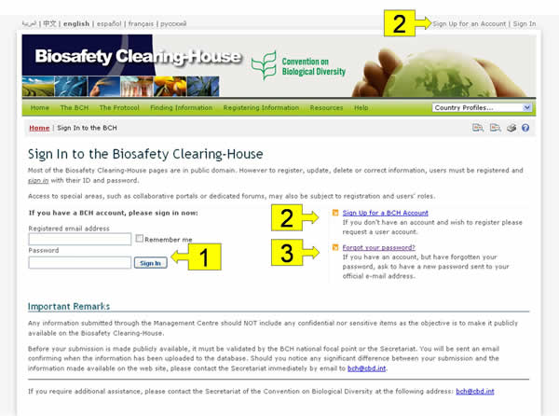

Figure 2

## The “Sign in” mechanism

In order to access the “Registering Information” section, you need to sign in with your registered BCH account. To sign in: (i) enter the email address which you used to register for a BCH account in the **Registered email address** field, (ii) enter the password in the **Password** field and (iii) click the **Sign In** button.

If you select the **Remember me** checkbox, the computer you are using will remember your email address (but not the password) the next time you sign in to the Management Centre.

## The “Sign up for a BCH account” links.

To register in the BCH click on the “Sign up for a BCH account” or «Sign up for an Account” link. These links open a page where you can request a “general user account” by entering your contact details and clicking the button “Submit request”.

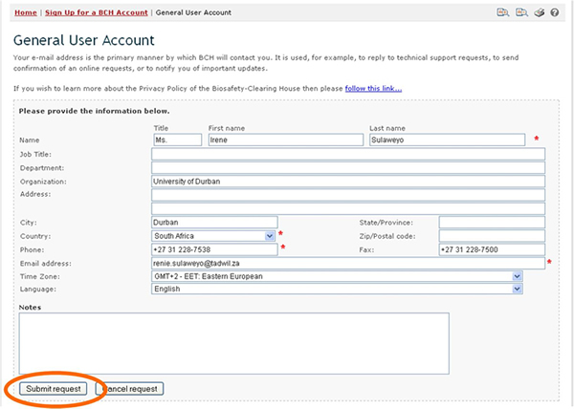

Figure 3

### Choosing a password

When your account is first created, a welcome message and a temporary password will be sent to the email address provided. As a security measure, you will be asked to change this password the first time you sign in to your account.

You can also change your password at any time by selecting the **Password Change** option in the left-hand menu of the **Personal Account** section (see “Password Change” section).

The Management Centre is protected against unauthorized registration through a secure system of information exchange called Secure Socket Layer (SSL). The email address and password system is used to control access to the website. As a consequence, it is of utmost importance to choose a password that is difficult to guess and by no means should it be given out.

Choosing a good password is very important. It must be fairly long and difficult to guess but also easy to remember. BCH passwords are case sensitive and must be between 8 and 64 characters long. You can use numbers and/or letters in the password.

Some advice on selecting your password:

* Avoid using “dictionary words” (i.e. words that appear in a standard dictionary).
* Use a combination of upper and lower case letters and numbers.
* Avoid using characters that don’t appear on a standard keyboard (e.g. Euro symbol) since they may not work correctly in all circumstances (e.g. if you need to sign in to your account while travelling).
* A popular method for selecting easy-to-remember passwords is to use letters and numbers from a phrase or song lyric. For example, “The Biosafety Protocol was adopted in January 2000” becomes “TBPwaiJ2000”.

## The “Forgot your password?” link

If you already have an account, but you do not remember your password, click on the **Forgot your password?** link. You will be requested to enter your registered email address. Then click on “Continue” button. A new password will automatically be sent to that email address.

If you change your email address, please update your account by using the “My profile” link in the right top corner of the web-site. In case you are the National Focal Point, contact the Secretariat to have your account updated.

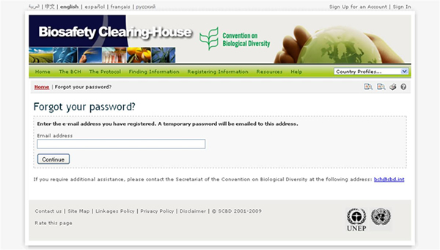

Figure 4

# The Management Centre main page

The Management Centre main page serves as the entry point for registering information in the BCH.

Once you are signed in, you can access to the following components of the Management Centre:

1. Register a new record;
2. Edit a published record;
3. Edit a draft record;
4. Records pending validation prior to publication
5. Personal Account;
6. Administration (only for NFPs).

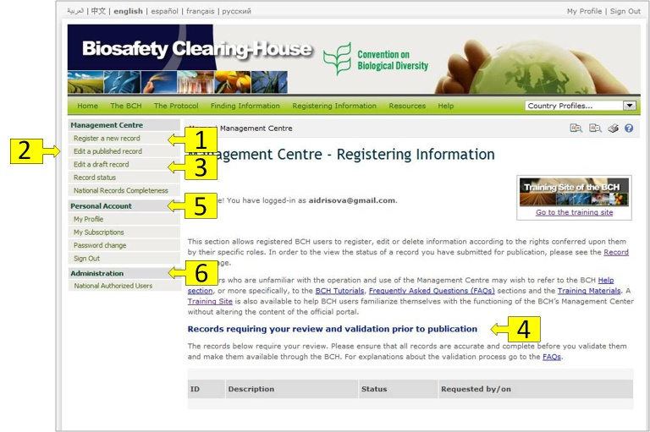

**Figure 5**

## Register a new record

By clicking on the **Register a new record** link in the left-hand menu, registered users can create records and make them available to the public through the BCH. In the BCH, the stored documents are called records.

The registering a new record process consists of the following steps:

* Select the type of record from the list of links provided;
* Complete all of the fields on the electronic registration forms;
* Click on the **Review** button to double check the completeness and accuracy of the information entered
* Click on the **Save changes** button; and
* Click on the **Submit for publishing** button to make the record public in the BCH.

There are two categories of information in the BCH: National Records and Reference Records

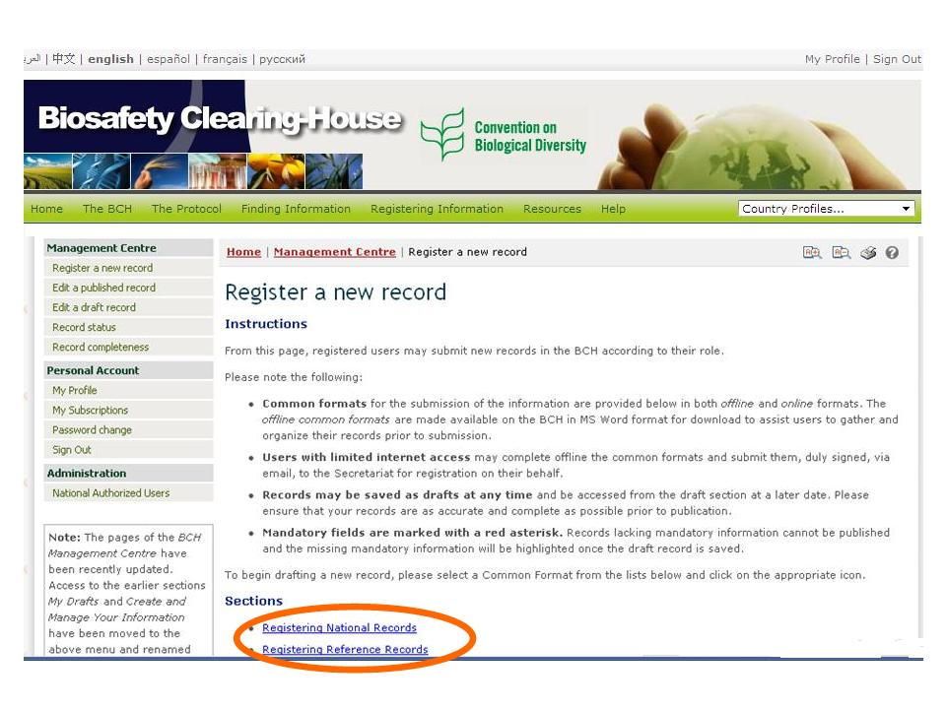

**Figure 6**

The types of record that registered users may submit depend on their role as follows:

* [BCH national focal points (BCH-NFPs)](https://bch.cbd.int/help/faq/#NFP) may register all [types of BCH records](https://bch.cbd.int/help/faq/#INF) with the exception of [National Focal Point records](https://bch.cbd.int/help/faq/#NFP). When submitted by BCH-NFPs, National Records are directly published while Reference Records are subject to [validation](https://bch.cbd.int/help/faq/#VAL) by the Secretariat prior to publication in the BCH.
* [National Authorized Users (NAUs)](https://bch.cbd.int/help/faq/#NAU) may also register all [types of BCH records](https://bch.cbd.int/help/faq/#INF) with the exception of [National Focal Point records](https://bch.cbd.int/help/faq/#NFP). When submitted by NAU, National Records are subject to [validation](https://bch.cbd.int/help/faq/#VAL) by BCH-NFP and Reference Records are subject to [validation](https://bch.cbd.int/help/faq/#VAL) by the Secretariat prior to publication in the BCH.
* [General registered users](https://bch.cbd.int/help/faq/#USE) may register all types of [Reference Records](https://bch.cbd.int/help/faq/#INF), subject to [validation](https://bch.cbd.int/help/faq/#VAL) by the Secretariat prior to publication in the BCH

The ***Register a new record*** page provides access to the following:

1. Categories of documents (national and reference records);
2. Names of the Common Formats;
3. Link to offline Common Formats;
4. Link to online Common Formats.

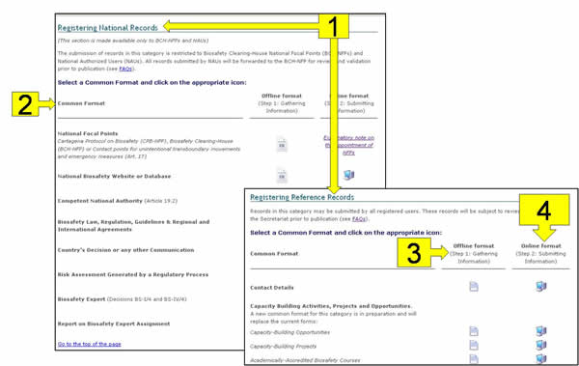

**Figure 7**

### Categories of documents: national and reference records

There are two categories of documents that can be submitted to the BCH: **national** and **reference** records.

The **national records** that can be submitted are the following:

|  |  |
| --- | --- |
| **National Documents** | **Purpose** |
| National Focal Points | Registering a National Focal Point (CPB, BCH or Article 17). |
| [National Website or Database](http://bch.cbd.int/resources/common%20formats/nationalrecord_02_webdatabases.doc) | Registering national websites and databases related to biosafety. |
| Competent National Authorities | Registering Competent National Authorities that are nominated and authorized by the governments for performing the administrative functions required by Article 19 of the Protocol. |
| [Biosafety Law, Regulation, Guidelines & Regional and International Agreements](https://bch.cbd.int/resources/common%20formats/nationalrecord_04_lawregguidelinesagreem.doc) | Registering any document pertaining to the national regulatory framework and relevant to biosafety or the transfer, handling and use of living modified organisms. |
| [Country's Decision or any other Communication](https://bch.cbd.int/resources/common%20formats/nationalrecord_05_decisionscommunications.doc) | Registering any national decisions or communications relevant to biosafety or the transfer, handling and use of living modified organisms. |
| Risk assessment generated by a Regulatory Process | Registering a summary or a report of a risk assessment or environmental reviews of LMOs generated by regulatory processes including, where appropriate, relevant information regarding products thereof, namely, processed materials that are of living modified organism origin, containing detectable novel combinations of replicable genetic material obtained through the use of modern biotechnology. |
| Biosafety Experts | Registering a Biosafety expert according to Decisions BS-I/4 and BS-IV/4 |
| Report on the assignment undertaken by the Biosafety Expert | Registering a Report on a Biosafety Expert Assignment according to Decisions BS-I/4 and BS-IV/4. |

The submission of national records is limited to BCH National Focal Points (BCH-NFP) and National Authorized Users (NAUs) pending BCH-NFP validation. The list of Common Formats for national records is therefore made available only to these users.

The submission of information regarding designation of National Focal Points is restricted to National Focal Points or Ministers of State and can only be registered by the Secretariat upon receipt of official written communications addressed to the Executive Secretary and endorsed by the relevant authorities (see below). Accordingly, this particular Common Format is only made available offline and cannot be submitted electronically.

* The designation of a *National Focal Point for the Cartagena Protocol on Biosafety* (CPB-NFP) must be endorsed by the National Focal Point for the Convention on Biological Diversity (CBD-NFP) or by a direct expression of the Government (i.e. a Minister of State).
* The designation of a *National Focal Point for the Biosafety Clearing-House* (BCH-NFP) must be endorsed by the National Focal Point for the Cartagena Protocol on Biosafety (CPB-NFP).
* The designation of a *Contact point for unintentional transboundary movements and emergency measures* (Art. 17) must be endorsed by the Biosafety Clearing-House National Focal Point (BCH-NFP).

The **reference records** that can be submitted to the BCH are the following:

|  |  |
| --- | --- |
| **Reference Documents** | **Purpose** |
| Contact details | Registering contact details of a person or organization. For instance, an organization could be a representative of the private sector, research institutions, NGOs (non-governmental organizations), IGOs (Intergovernmental organizations), etc. |
| Capacity Building Activities, Projects, and Opportunities | Registering information concerning capacity building opportunities, projects and activities, such as fund grants, scholarships, technical assistance, training workshops, discussion forums and others. |
| Capacity-Building Needs Assessment | Registering information about country needs regarding biosafety capacity building. This includes main areas where capacity building is needed, and thorough details about the specific activities or resources needed. |
| Biosafety Organization including Laboratory for detection and identification of LMOs | Registering a Biosafety Organization for inclusion in the Directory of Biosafety Organizations. These organizations are involved in activities related to the application of the protocol on biosafety including registration of work summaries and contact details. |
| [Biosafety Information Resource Centre (BIRC)](https://bch.cbd.int/resources/common%20formats/referencerecord_04_birc.doc) | Registering information for inclusion in the Biosafety Information Resource Centre (BIRC). It consists of an electronic catalogue of biosafety-related publications and information resources. It aims to provide wider access to the biosafety-related resources and information available, as well as spreading their usage. |
| BCH News | Submitting news to the BCH. |
| Risk assessment generated by an independent or non-regulatory process | Registering risk assessments other than those generated by a regulatory process. |
| Living Modified Organisms (LMOs) | Registering summarized information on Living Modified Organisms, including the transformation event, the genetic modification, and the Unique Identifier Code. |
| Genetic element | Registering information on genes or DNA sequences used in LMOs. It refers to nucleic acid sequences that were used to create LMO registered in the BCH. |
| Organism | Registering information on parental, recipient or donor organisms related to the LMO registered in the BCH. |

**All registered BCH users may submit reference records**. However, they will only be made public once they have been **validated by the Secretariat**.

**Note**: both national and reference records can contain, besides their own information, links to other Common Formats. For example, an LMO record can refer to other records such as an inserted gene, the parental organism, the contact details of an applicant, etc. (Figure 8)

Referencing other records greatly reduces the need to manually enter duplicate information. For example, you can enter the contact details of a Competent National Authority (CNA) only once and then simply refer to that record when registering all of the decisions that CNA has taken (i.e. rather than entering the contact details every time a decision is registered).

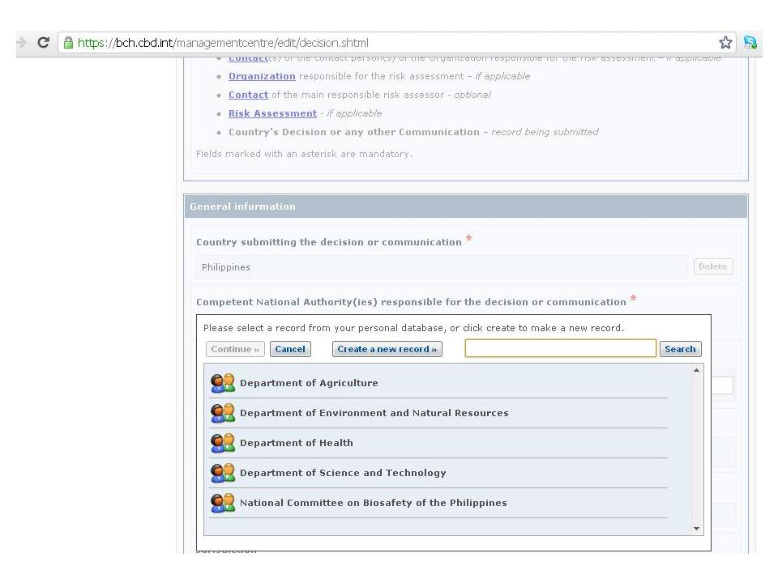

**Figure 8**

### Common Formats

The Common Formats are formal specifications of the data that can be registered in the BCH. They enable users to store and display BCH information in a standardized way, not depending on the country, organization or person from which the information comes.

Specific Common Formats are available for each type of document, in both national and reference category of records, in six official UN languages. As information can be submitted to the BCH both on-line (using the BCH Management Centre) and off-line (via email, fax or postal mail), the Common Formats for each record type are available both for on-line registration and for download in Ms Word format (see sections below).

#### Offline Common Formats

Offline Common Formats are standard forms, made available on the BCH in MS Word format for download, to assist users to gather and organize information prior to submission. They are off-line copies of the online registration forms and can be found under the BCH section **Resources (**<http://bch.cbd.int/resources/common-formats/>).

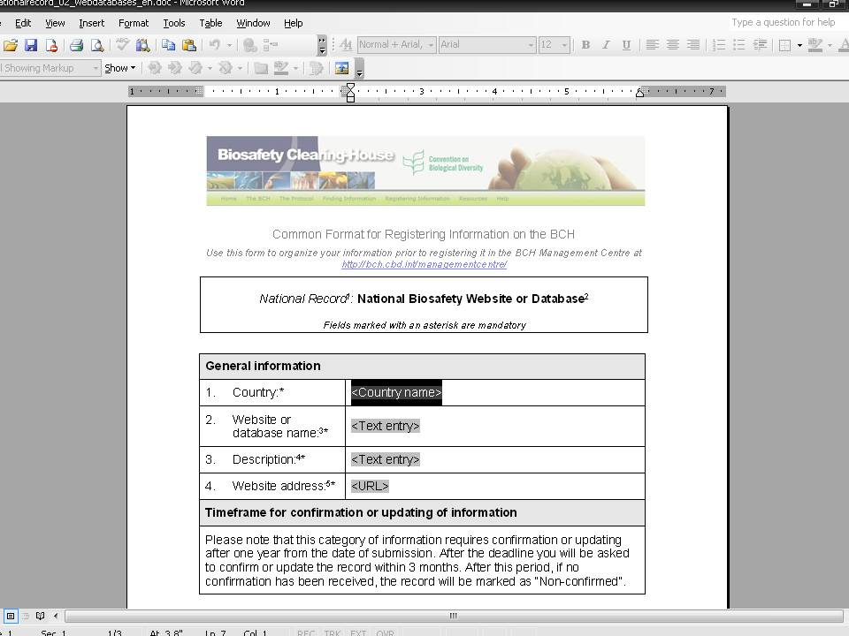

**Figure 9**

It is preferable for BCH information to be submitted online through the Management Centre. However, users with limited Internet access may complete Common Formats and submit them, duly signed, to the Secretariat by email, fax or postal mail (however, Common Formats should only be faxed or mailed if sending them by email is impossible) to the following addresses:

Email: bch@cbd.int

Fax: +1 514 288 6588

Postal Address: Secretariat of the Convention on Biological Diversity (SCBD)

413 St-Jacques, Suite 800

Montreal, QC, Canada, H2Y 1N9

Section 5 of this Manual describes how to complete the offline Common Formats.

#### Online Common Formats

The online Common Formats can be accessed by selecting the link **Register new record** from the left-hand menu of the BCH Management Centre. The specific Common Format can then be opened by clicking the corresponding computer icon  next to the record type. The whole BCH is made available in all 6 languages of the United Nations and the selection of the language in use determines the language in which the online Common Format is made available. Please note that the list of the available online Common Formats depends on the role of the user (see section “Categories of documents: national and reference records”).

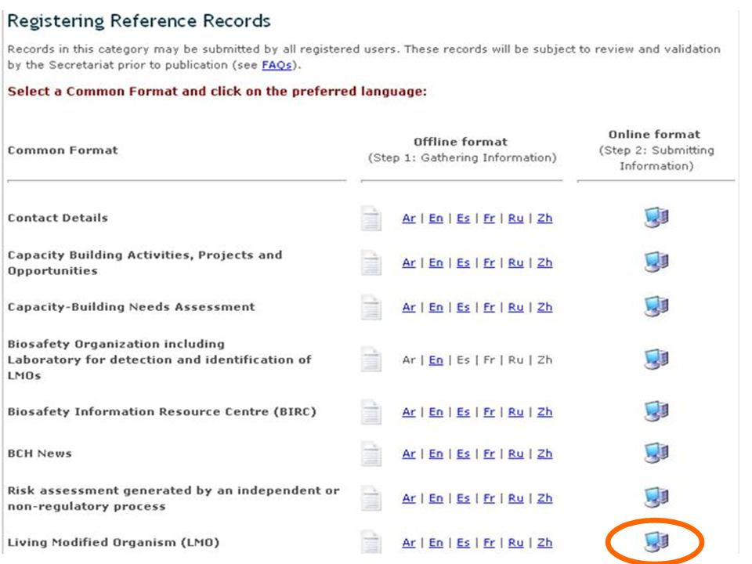

**Figure 10**

### Using the online registration forms

The figures below show some of the online registration forms and highlight their main types of fields and buttons.

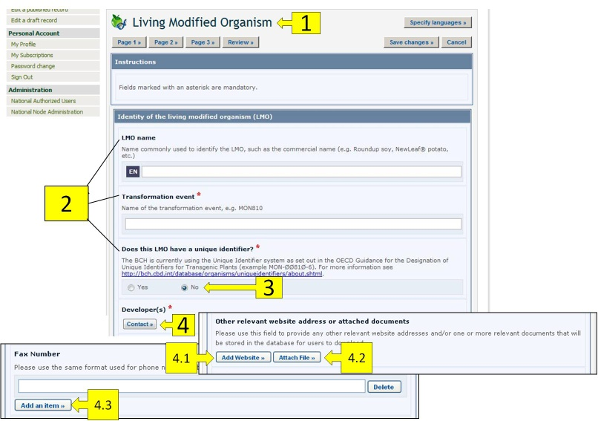

**Figure 11**

1. **Record Name:** The box on the top of the online form shows the type of information you are registering.
2. **Field names:**  The bold text is the field name in which information is to be entered.
3. **Radio buttons:** Click on the option you would like. Note that you can only select one of them.
4. **Add reference buttons:** These buttons access a drop-down menu of records already registered in the BCH that you can link to the record you are working on. If the record is not in the menu, you can create a new record with the new information by clicking on the **Create a new record** button. A second Common Format will appear on the screen where you will be able to create the new record. Once you have finished entering the information and saved the new record, you will return to the original Common Format you were working on. Some fields allow you to add references to other sources of information than BCH records:
   1. **Add Website:** Enables you to add a link to a website**.** Because links often become broken over time, it is alwayspreferable to attach a file instead of providing a link so that it is permanently available.
   2. **Attach File:** Enables you to attach a file.You can attach files to your records in any language (“Attach File” button). However, it is highly recommended to provide courtesy translations of the documents in one or more of the United Nations official languages.
   3. **Add an Item:** Enables you to add further information (e.g. more telephone numbers).
5. **Checkboxes:** When there are short lists of controlled vocabulary (i.e. a pre-defined list of possible terms; see the BCH glossary for definition), they are sometimes presented as checkboxes. To add or select one or more terms, click on the checkboxes that appear next to them.
6. **Other** button**:** If the term you are looking for does not appear in the controlled vocabulary list, click the “Other” button. Select the term that most closely describes your term, or if you do not have found any closely term check the checkbox and enter a new term.

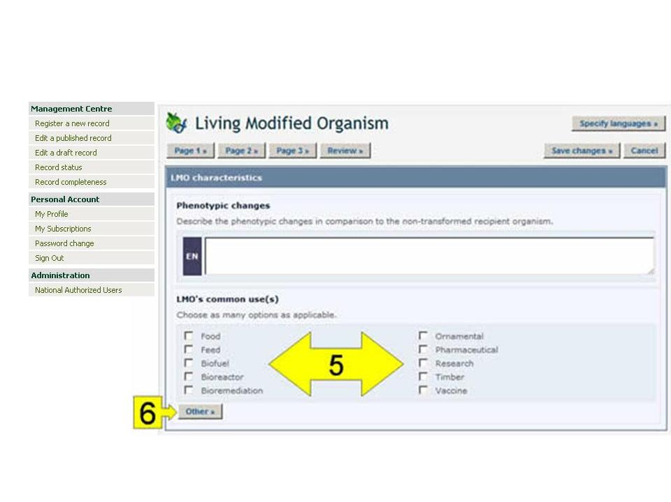

**Figure 12**

1. **Select button** Clicking this button opens a dropdown menu of terms from the controlled vocabulary list. Click on the term you want to select and click on “Continue”.

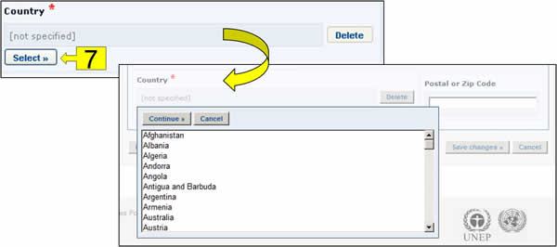

**Figure 13**

1. **Review** button**:** After entering all of the information you can click on the review button and view your record as it will appear upon publication. It is very important to review the record for completeness and accuracy prior to submission for publication.If there are errors in the fields, they will be displayed with an error description for each one. Mandatory fields that are not completed are also highlighted. In order to make the necessary changes, return to the registration pages.
2. **Save changes** button**:** Clicking on this button opens a window where you are given the option of (i) submitting record for publishing or (ii) saving it as a draft for access at a later time.
3. **Cancel** button**:** Clicking on this button opens a window and you are given the option of discarding the changes made to the draft by clicking ‘Confirm’.
4. **Page number** buttons**:** In the upper and lower part of the registration page there are buttons to navigate through the different pages of the Common Format**.**
5. **Language selection** button**:** see “Language selection” section below.

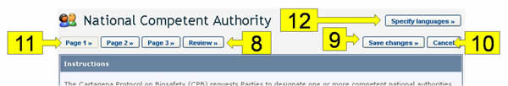

**Figure 14**

#### Mandatory fields

When creating new records, BCH users must make sure that the information is as accurate and complete as possible prior to publication. The mandatory fields are marked with a red asterisk. Records in which the mandatory information has not been provided will not be published.

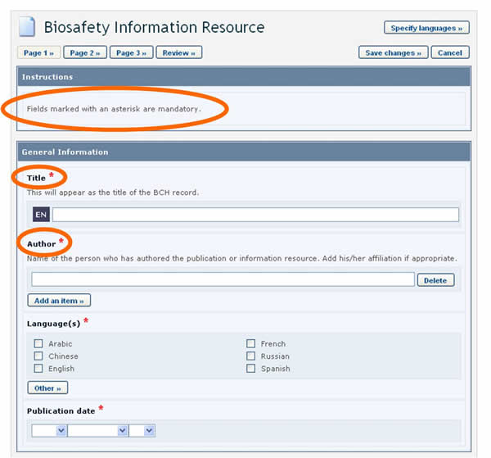

**Figure 15**

#### Language selection

BCH users can choose the language or languages in which to register BCH records. However, it is required that all records are submitted in at least one of the six official UN languages (i.e. Arabic, Chinese, English, French, Russian and Spanish), in addition to any other language(s) of choice. Clicking the **Specify Language** button, which appears at the top of the online registration form, opens a window which allows you to select the languages in which to enter information. The checkboxes allow for selecting official UN languages, while the dropdown menu allows for selecting any other language. Once the languages are selected, fields in the form will display an entry for each selected language.

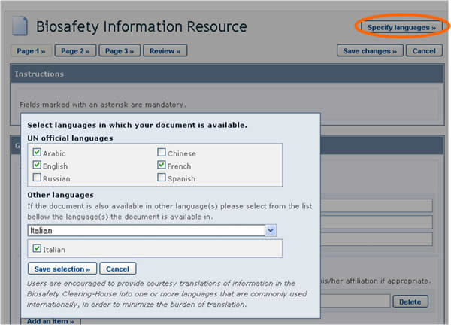

**Figure 16**

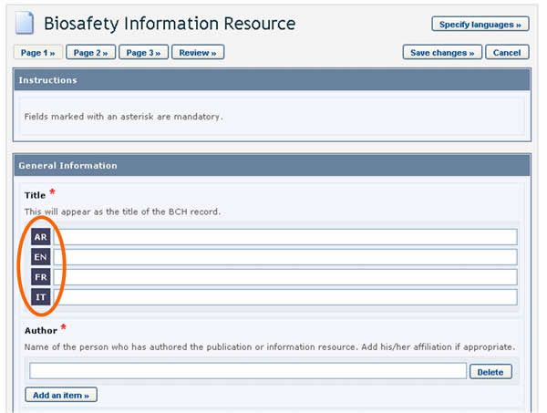

**Figure 17**

#### References to other records

While entering information, you may be asked to refer to an existing BCH record (i.e. some fields refer to information that is registered in another document) or create a new one based on a different Common Format

Let us take as an example the references to the recipient organism or parental organisms that are required when registering an LMO.

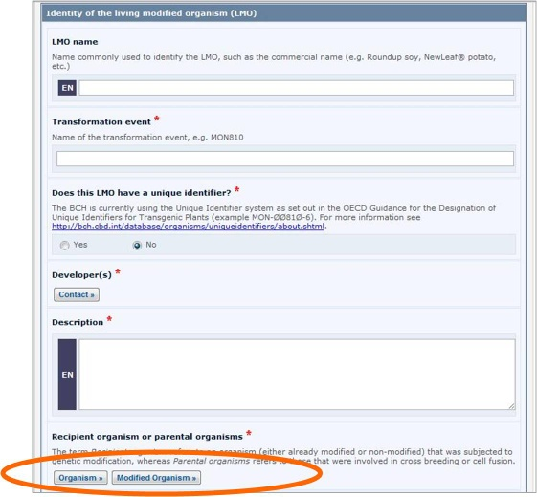

**Figure 18**

LMO records require that a reference to another record is provided in the “Recipient organism or parental organisms” field. By clicking on the **Organism** or **Modified Organism** buttons, you can select a reference to an existing document from the list that appears.

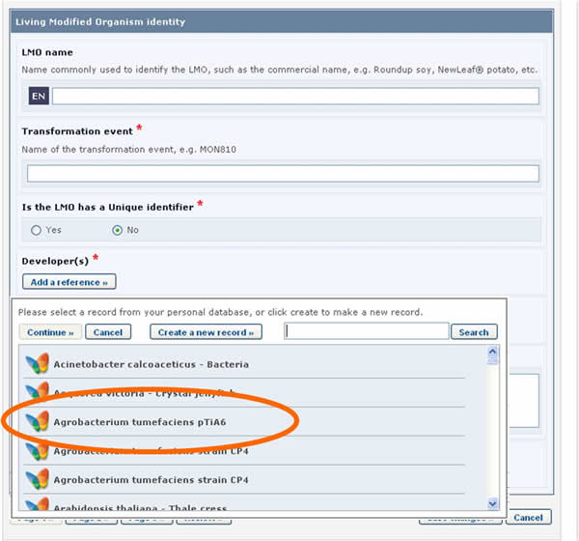

**Figure 19**

If the reference that you need is not available in the list (i.e. it has never been registered in the BCH), you need to create a new record using the button “Create a new record”.

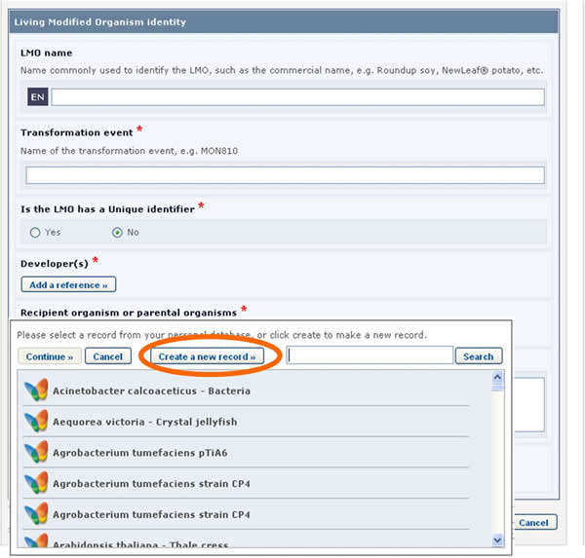

**Figure 20**

In this case, the form to be completed will appear on the screen *over* the one that was previously being edited. It will need to be completed and published before it is made available in the drop-down reference list of the previous form.

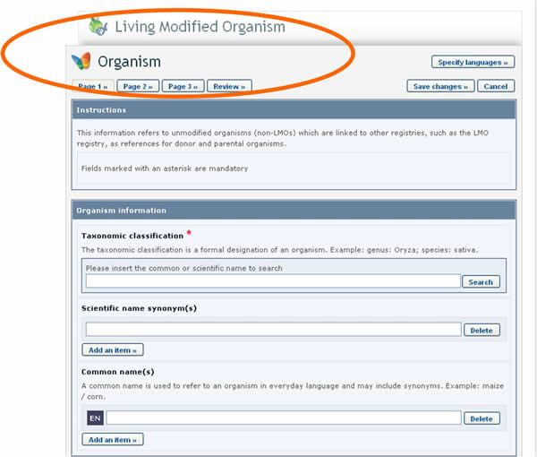

**Figure 21**

See section “Completing offline Common Formats” for a description about how this is implemented in offline common formats.

#### Fields displayed according to answers provided previously.

In some cases, when entering information, questions will be asked to the user. Depending on the answer provided, additional fields will appear on the screen to be completed.

For example, when registering “Genetic element” record and the “Protein coding sequence” option is selected under the “Category of a DNA sequence” section, a new section called “Characteristics of the protein coding sequence” will appear on the screen.

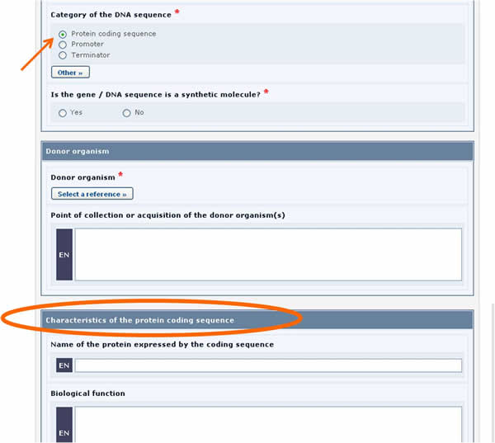

**Figure 22**

Similarly, if the “Tolerance to abiotic stress” option is selected, a new section will appear displaying the list of all possible tolerances to abiotic stress.

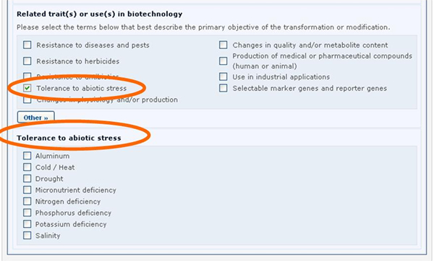

**Figure 23**

See section “Completing offline Common Formats” for a description about how this is implemented in offline common formats.

#### Additional Information fields

All of the Common Formats provide an “Additional Information” field at the end of the record where you can add text, provide an internet address (URL), and attach additional file(s).

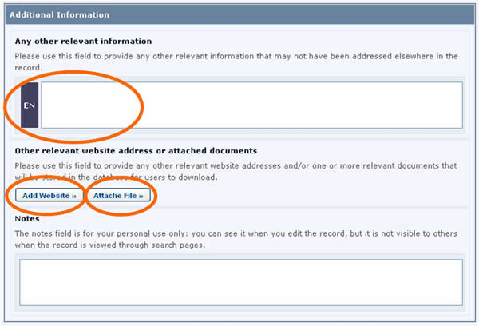

**Figure 24**

#### Timeframes for confirming or updating document content.

In order to keep certain records, such as Competent National Authorities, up-to-date, they require confirmation or update after one year from the date of submission. After the deadline, the author of the record will be asked to confirm or update the record within 3 months. If this has not been done at the expiry of this period, the record will be marked as “Not Confirmed”.

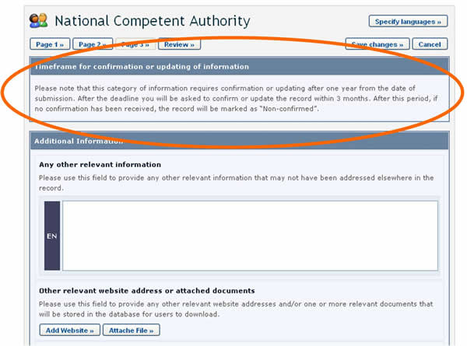

**Figure 25**

The expiration period for the “Biosafety expert” records is four years from the last update of their information, after which they will be deleted unless re-nominated.

In some cases, the expiration period is optional and the author is asked, when registering the document, to indicate whether confirmation or updating will be required after two years from the date of submission. Choosing this option will mean that the author will receive a reminder after two years to keep the information up-to-date.

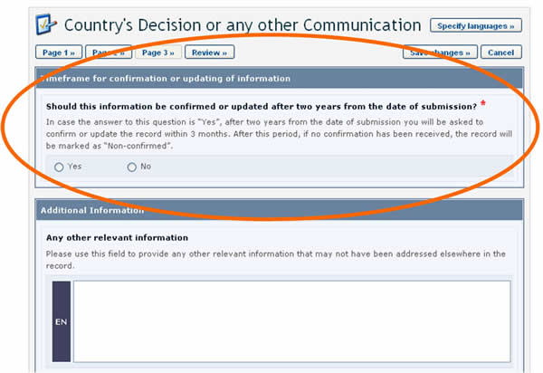

**Figure 26**

|  |  |
| --- | --- |
| **National records** | |
| **Type of document** | **Timeframe** |
| National Focal Points | One year (mandatory) |
| National Biosafety Website or Database | One year (mandatory) |
| Competent National Authority | One year (mandatory) |
| Biosafety Law, Regulation, Guidelines & Regional and International Agreements | Two years (optional) |
| Country's Decision or any other Communication | Two years (optional) |
| Risk Assessment Generated by a Regulatory Process | Two years (optional) |
| Biosafety Expert | Four years (mandatory) |
| Report on the Assignment undertaken by the Biosafety Expert | No confirmation or updating required |
|  | |
| **Reference records** | |
| **Type of document** | **Timeframe** |
| Contact Details | One year (mandatory) |
| Capacity Building Activities, Projects and Opportunities | One year (mandatory) |
| Capacity-Building Needs Assessment | Four years (optional) |
| Biosafety Organization, including Laboratory for detection and identification of LMOs | One year (mandatory) |
| Biosafety Information Resource Centre (BIRC) | No confirmation or updating required |
| BCH News | No confirmation or updating required |
| Risk assessment generated by an independent or non-regulatory process | Two years (optional) |
| Living Modified Organism (LMO) | No confirmation or updating required |
| Genetic element | No confirmation or updating required |
| Organism | No confirmation or updating required |

### Reviewing and saving a record

The “Review” button found at both the top and the bottom of the Common Format, allows BCH users to review their information as it will appear in the record when published.

It is very important to review the record for completeness and accuracy prior to submission for publication.

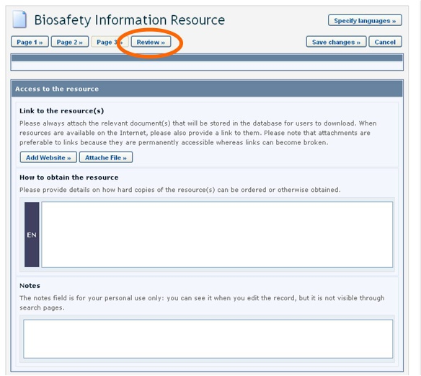

**Figure 27**

Clicking the review button opens the review page. If there are errors in the fields, they will be displayed with an error description for each one. Mandatory fields that are not completed are also highlighted. By clicking on the “Edit” link, you return to the field that needs to be modified. If you cannot complete the form at that time, it is recommended that you save it as a draft.

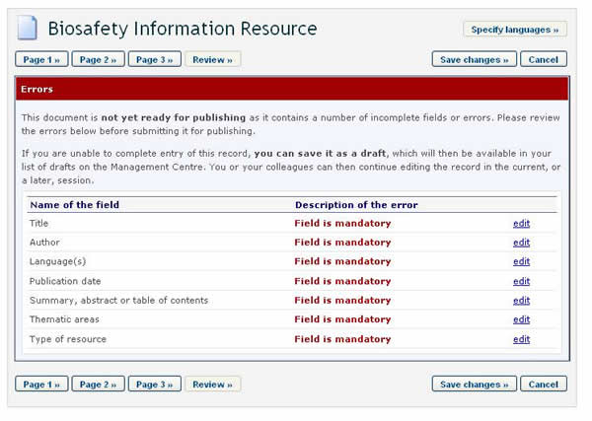

**Figure 28**

The “Save Changes” button, at both the top and the bottom of the online Common Formats, allows you to a) Submit the record for publishing or b) Save it as a draft. If you choose the latter, a saved draft will then be available in the “Edit a draft record” section for access at a later time. And when you have finished entering all information and chose the “submit for publishing” option, the record will go through the validation process (see section below).

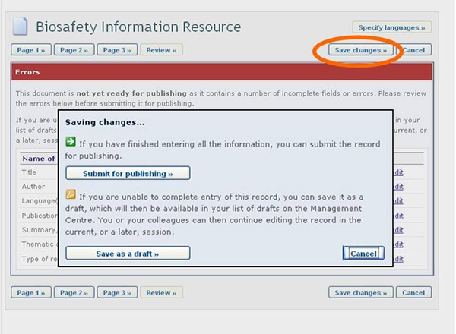

**Figure 29**

The “Cancel” button, at both the top and the bottom of the online Common Format, allows you to cancel the changes you have made.

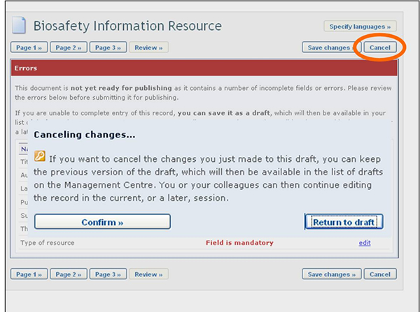

**Figure 30**

### Validation

In order to ensure the completeness and accuracy of information made available through the BCH, most records will require **“validation”**, i.e. approval for publishing. National records registered by BCH-NFPs are automatically validated and immediately made available through the BCH.

All **national records** registered by National Authorized Users must be validated by the relevant BCH-NFP prior to publication. They are forwarded to the BCH-NFP’s section of Records pending validation prior to publication for review for accuracy and completeness.

All **reference records** must be validated by the Secretariat prior to publication. Therefore independently from the role of the user submitting the information, all reference records submitted to the BCH are forwarded to the Secretariat.

Once the record is validated, it becomes available to the public.

The figure below summarizes the general steps of registering information in the BCH.

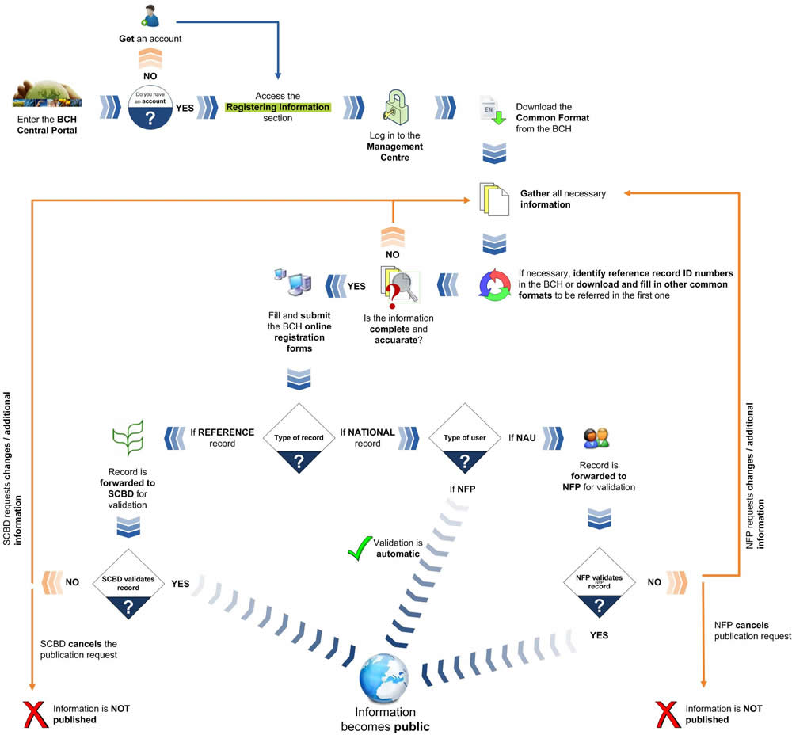

**Figure 31**

## Edit a published record

In the left-hand menu of the Management Centre there is a link to “Edit a published record” By clicking it, you can edit or delete any existing record that you have previously published in the BCH. You can filter by record types in order to quickly identify which records you want to work on.

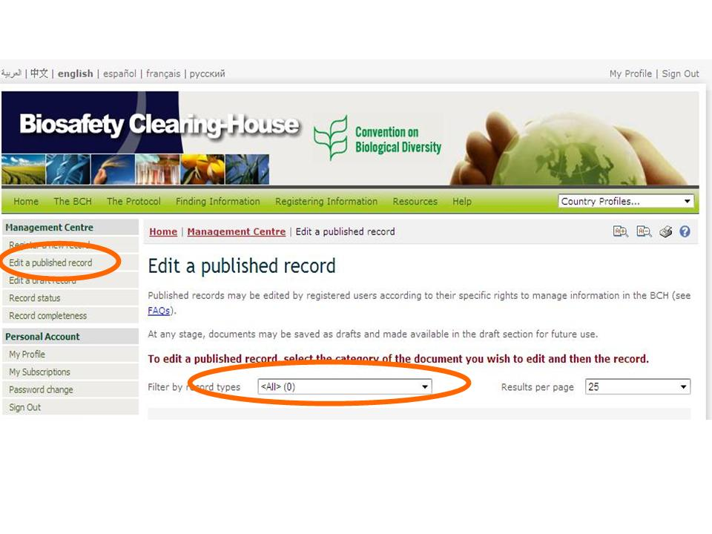

**Figure 32**

## Edit a draft record

By clicking on the “Edit a draft record” link in the left-hand menu, you may edit or delete any existing drafts that you have previously saved.

As with the “Edit a published record” function, you can filter the record types in order to quickly identify which records you want to work on. Please note that Draft National Records saved here may be accessed by the BCH-NFP and any National Authorized User for editing and/or publication.

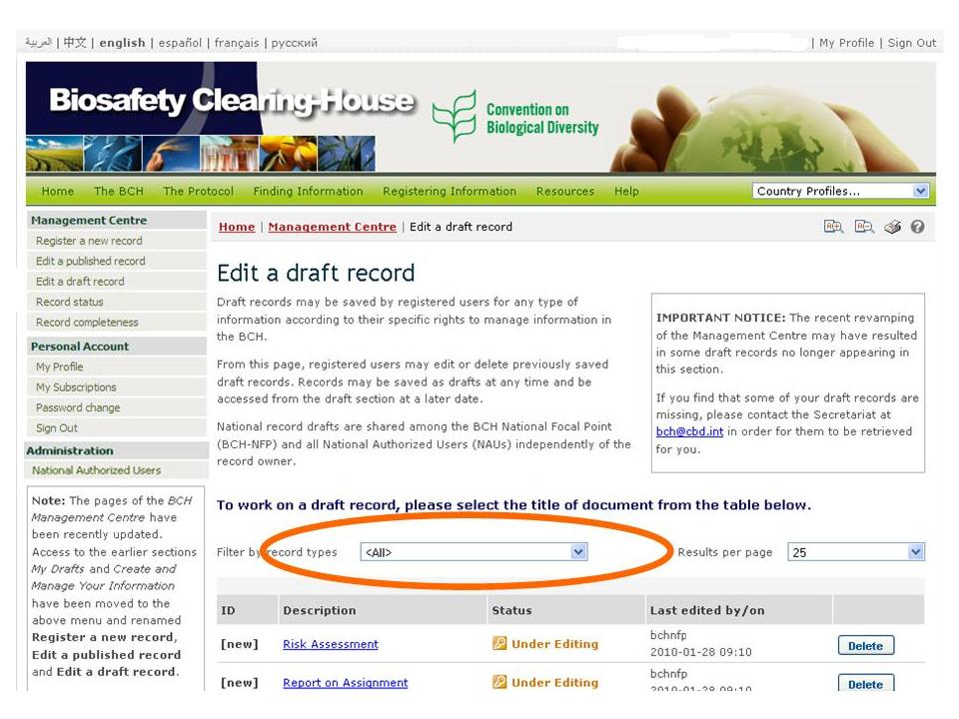

**Figure 33**

## Validate pending records

In the Management Centre, BCH-NFPs will also find, under the heading “Records requiring your review and validation prior to publication”, any records that need to be reviewed for completeness and accuracy prior to publication in the BCH.

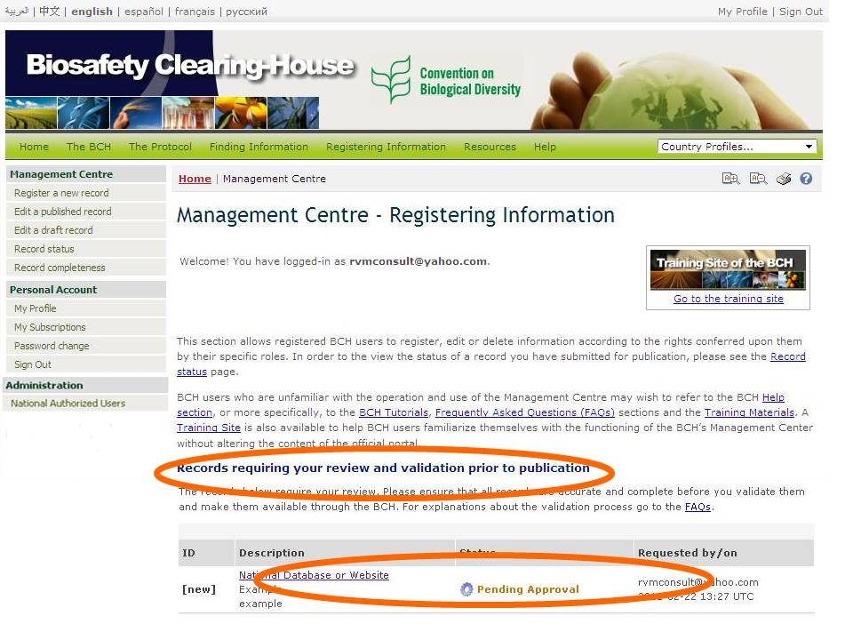

**Figure 34**

## Record Status

Clicking the “Record status” link in the left-hand menu opens a page where you can see the status of your records submitted for publishing and pending validation by BCH-NFP or the Secretariat. Once your request is completed, it will appear under the “Completed requests” section of the page and remain there for 30 days. After that it will be automatically removed from the list. You can also manually delete requests from the list by clicking on button “Hide”.

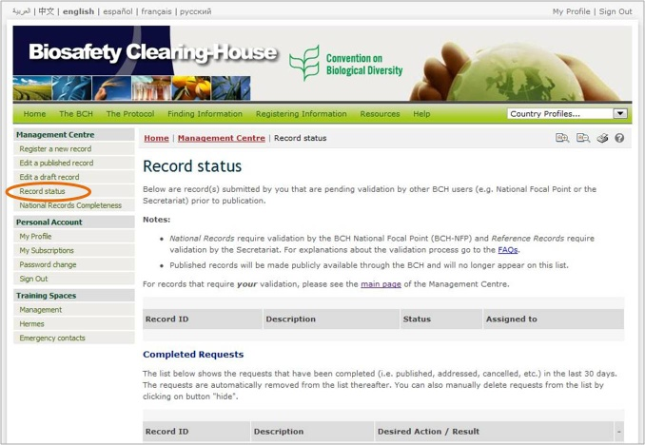

**Figure 35**

## National Records Completeness

The COP-MOP-5 held in Japan in October 2010 has decided on some fields in the Common Formats to be mandatory in nature. As records submitted earlier may lack some of the mandatory information, they need to be reviewed and completed.

The new BCH section “National Records Completeness” provides the BCH-NFP and NAUs with national records where mandatory fields were not filled-out.

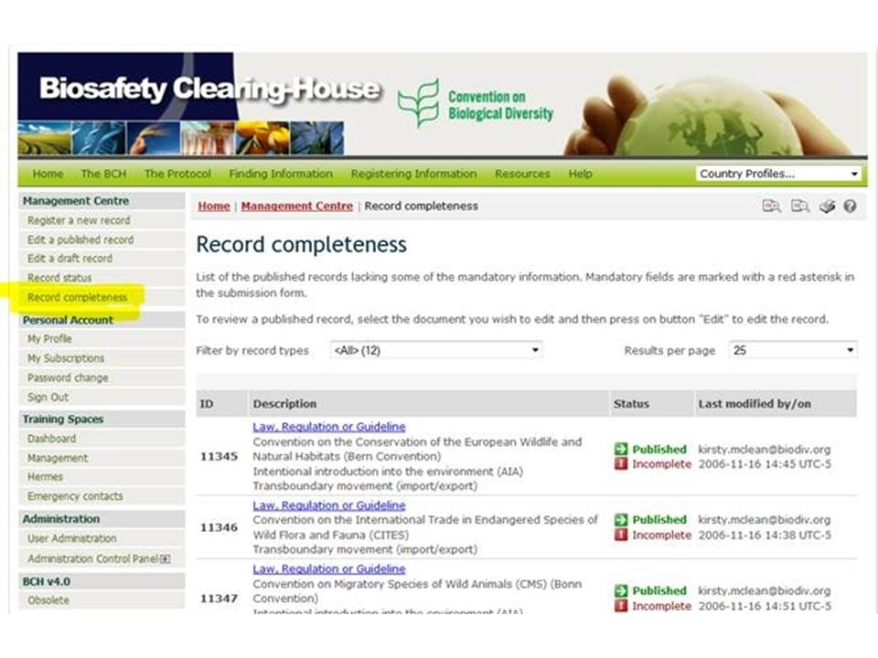

**Figure 36**

## Personal Account

In the section “Personal Account” you can access your profile, which contains your contact details. Please ensure you keep this page up to date as your contact details change.

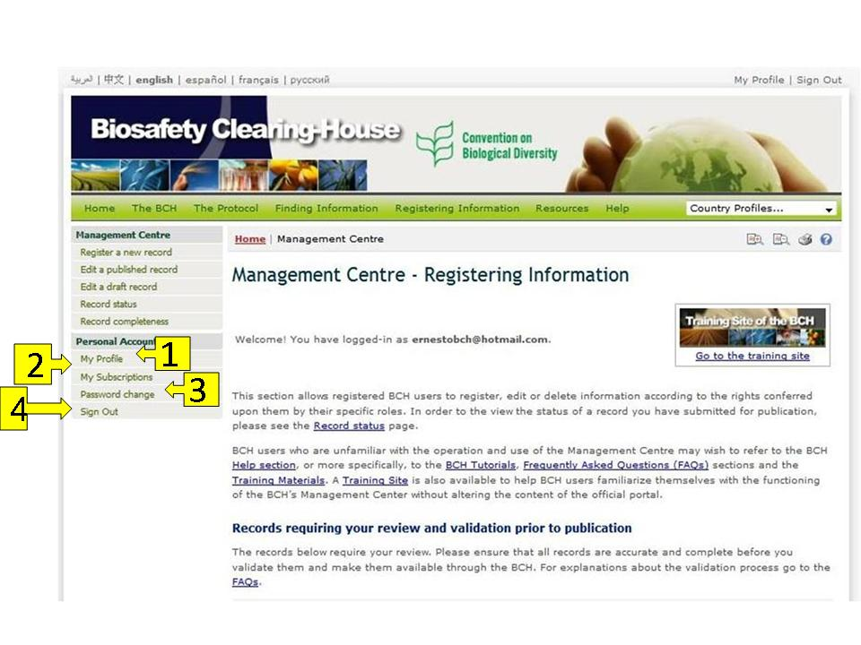

**Figure 37**

The section provides access to each of the following components:

1. My Profile
2. My Subscriptions
3. Password change, and
4. Sign out

### My Profile

By clicking on the “My Profile” link you can access the profile update page where you can update your personal data. Once you have updated the information, you can confirm your changes by clicking the “Update my profile” button located at the bottom of the page.

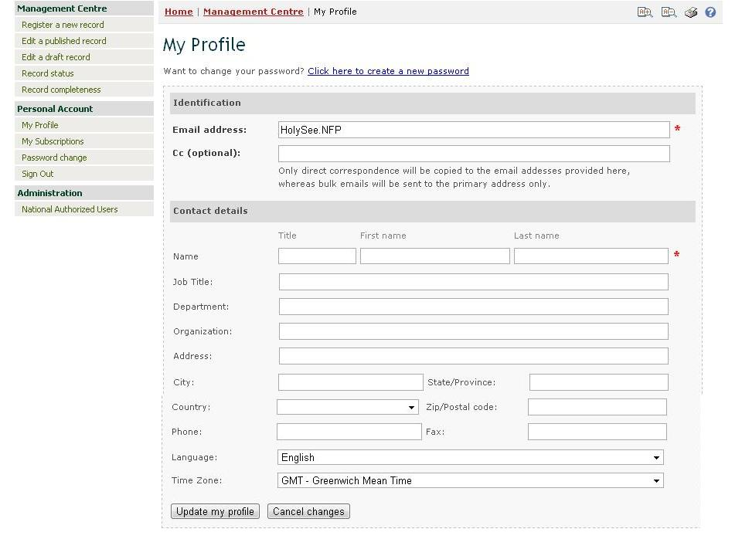

**Figure 38**

### My Subscriptions

By clicking on “My subscriptions” link you access the page where you can subscribe to the BCH mailing lists, as well as change or cancel your subscriptions.

Select the mailing lists you want to subscribe to by clicking on the corresponding options. Also select the frequency you would like to receive the information. You can confirm changes in your subscriptions by clicking the “Update my subscriptions” button located at the bottom of the page.

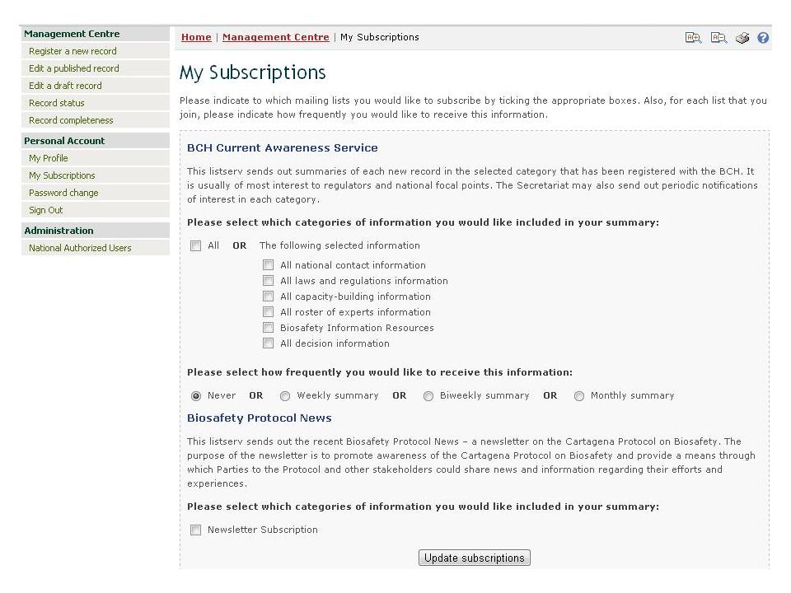

**Figure 39**

### Password change

By clicking on “Password change” link you access the page where you can change your password. For this, provide your current password and then enter the new one. Enter the new password again for confirmation and click the “Continue” button.

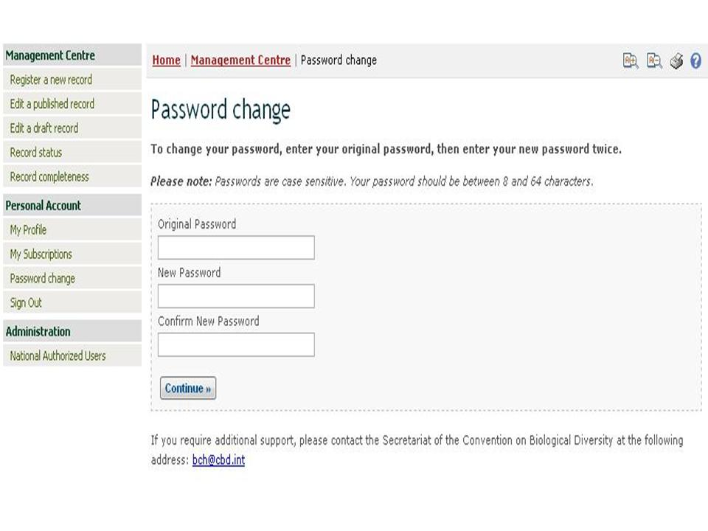

**Figure 40**

### Sign out

The “Sign out” link of the left-hand menu allows you to close your session. You can also find this link at the top right corner of the BCH web-site. For security reasons, it is highly recommended to always close your session when you finish working on the BCH.

## Administration (BCH - National Focal Points only)

BCH-NFPs have access to the restricted section “Administration”, which is not visible for other BCH users. It contains the link “National Authorized Users” that opens a page where BCH-NFPs can create and manage National Authorized Users (NAUs) as well as to extend administrator roles for the Hermes national node, where applicable.

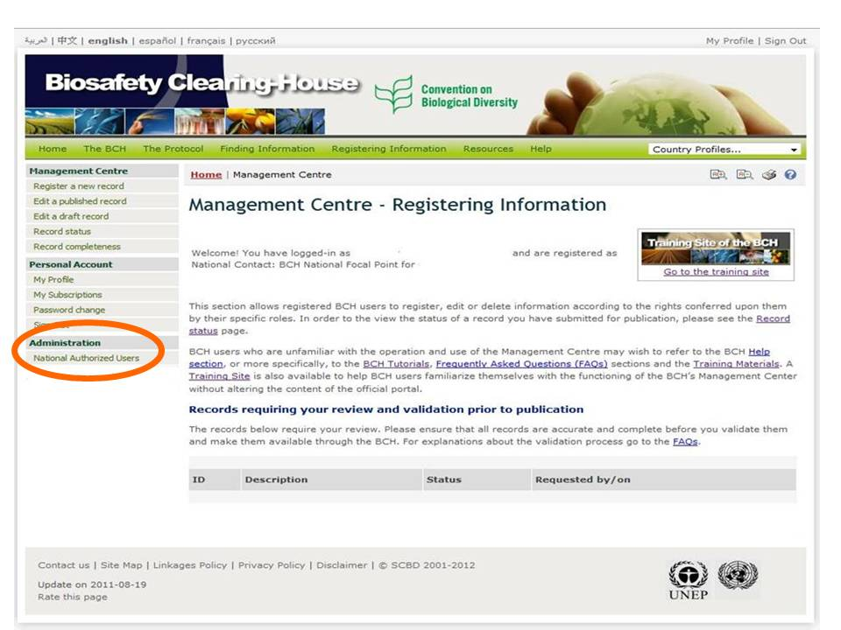

**Figure 41**

### National Authorized Users

In some instances, BCH-NFPs may wish to delegate to National Authorized Users (NAUs) some or all of the responsibilities of registering information in the BCH or managing the Hermes instance of the BCH national node. NAUs can create and manage draft records in all of the BCH’s categories of information (with the exception of [registering National Focal Points](http://bch.cbd.int/help/faq/#NFP)). However, all new records created by NAUs, as well as any modifications made to existing records, are subject to [validation](http://bch.cbd.int/help/faq/#VAL) prior to publication in the BCH either by the BCH-NFP, in the case of [National records](http://bch.cbd.int/help/faq/#INF), or by the Secretariat in the case of [Reference records](http://bch.cbd.int/help/faq/#INF).

The process for creating a new NAU is as follows:

1. Log onto the Management Centre (at http://bch.cbd.int/managementcentre/ );
2. Click on the “National Authorized Users” link in the left-hand menu under the Administration heading;
3. Click the «Add Authorized User” button at the bottom of the page;

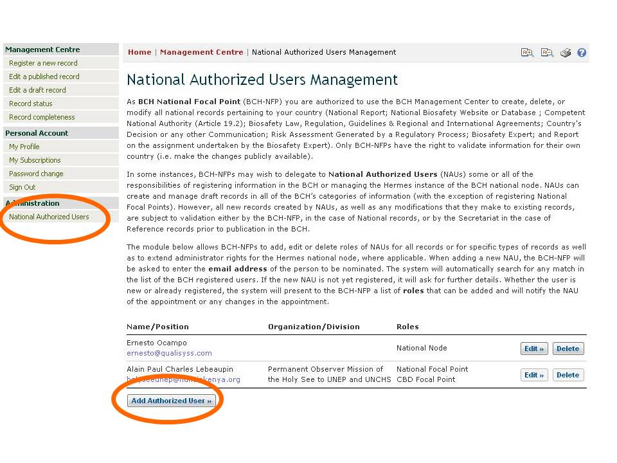

**Figure 42**

1. In creating a NAU, enter the email address of the person on the space provided in a box and click the «Search» button. The system automatically searches if there is a match to the email you provided.

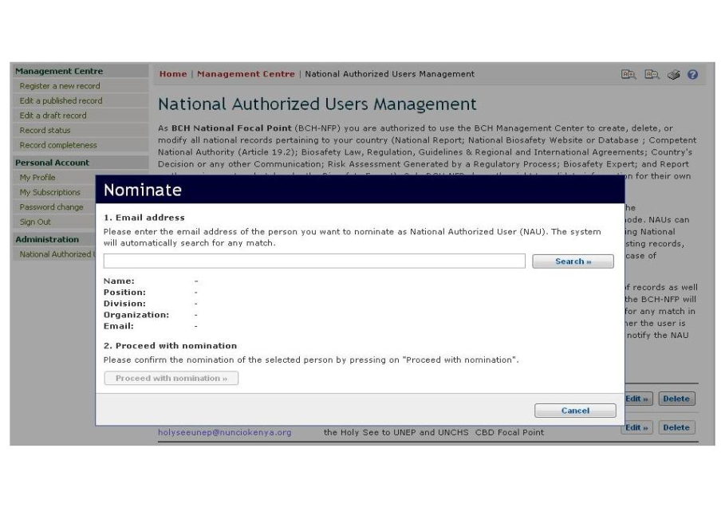

**Figure 43**

1. If the email address you provided yields a match, you may now proceed by clicking the “Proceed with nomination” button. And if the specified email address does not correspond to any existing BCH User Account, you can proceed with nomination by initiating the creation of a new BCH User Account. In this case, the new user will be asked to confirm his/her participation and complete contact details.

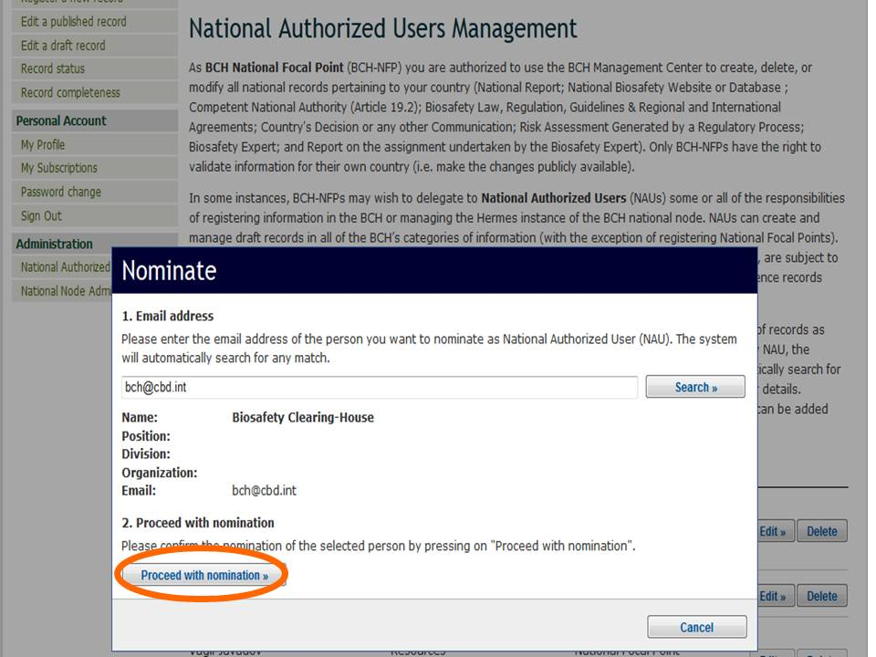

**Figure 44**

1. Select the role(s) for a new NAU from the list of roles by ticking corresponding checkboxes and click on the “Proceed with changes” button to assign the role(s) to the user. You can also modify roles of the existing NAU by clicking the link “Edit” next to the name of the NAU. Once you finished with nomination or changing roles of the NAU, the system will notify the NAU of the appointment or any changes in the appointment.

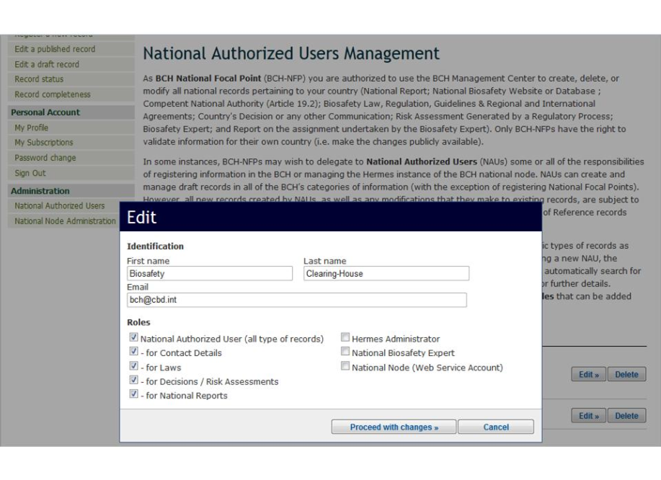

**Figure 45**

1. To remove a NAU from the list, click on the “Delete” button, and an advice will appear on the screen. Click on the button “Proceed” if you want to effect the deletion or “Cancel” so as the action will not materialize.

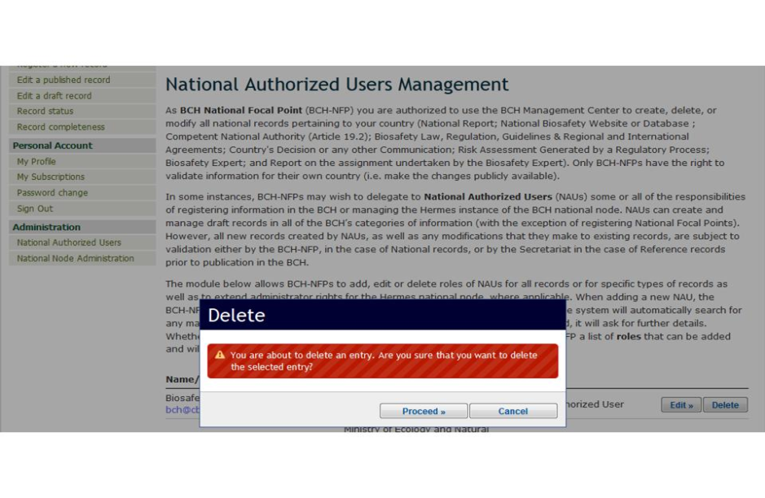

**Figure 46**

# Completing offline Common Formats

Offline Common Formats are standard forms, made available on the BCH to assist users in gathering and organizing information prior to submission. They are offline copies of the online registration forms and available for each type of record, in six official UN languages.

Offline Common Formats can be accessed in the Management Center by selecting the link “Register new record”from the left-hand menu or in the BCH section “Resources” by selecting the corresponding link from the drop-down menu on the BCH navigation bar. *Please note that while in the “Resources” section you can find the offline common formats for all types of records, the list of the offline common formats available for download in the Management Center depends on the user’s role (i.e. general BCH user will find there only common formats for reference records).* The specific common format can then be downloaded as MS Word document by clicking on the link with the preferred language.

The forms contain several different fields in which to enter information. As in the online Common Formats, there are fields which are mandatory and must be completed before the record can be published. Also, there are fields in which different kinds of information are required (text, numbers, dates) and entering the wrong type of information (e.g. adding text in a number-only field) will block the publishing of the record.

The following list describes the kinds of fields that can be found on the forms.

1. **Checkboxes**: Select the options that correspond from the list.
2. **Text entry**: Enter free text

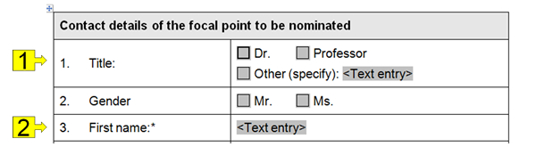

**Figure 47**

1. **Reference to another record**: As in online registration forms, some fields may contain a reference to another record. In this case a “BCH record number” is entered; that is, the number that the referenced record was assigned in the BCH. Sometimes the record to be referenced does not yet exist. In these cases you may wish to create the record to be referenced using the appropriate offline Common Format and attach it.

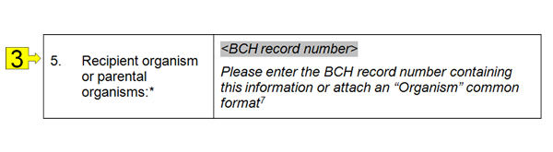

**Figure 48**

1. **URL and website name**: Provide the name and internet address of a website.
2. **Attachment**: Attach a document to the offline Common Format.

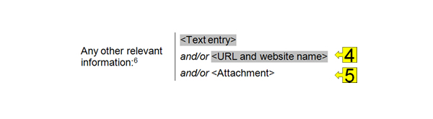

**Figure 49**

1. **Date**: Enter a valid date using the specified date format. For example, if the specified date format is ‘YYYY-MM-DD”, then the date “20-jan-2010” must be entered as “2010-01-20”.
2. **Registered email address**: Enter an email address that was registered in the BCH to identify the referenced person.

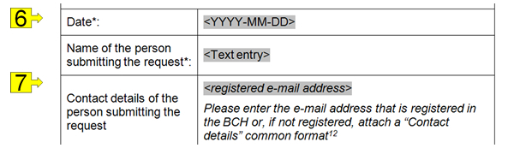

**Figure 50**

1. **Value**: Enter a numeric value
2. **Currency**: Enter a currency

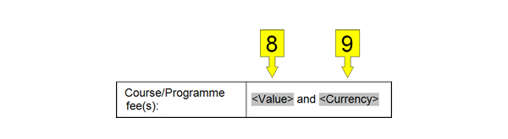

**Figure 51**

1. **Country name**: Enter a valid country name
2. **Language**: Enter a language or a valid language code

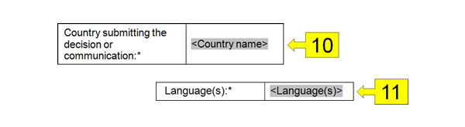

**Figure 52**

1. **Dropdown list**: A list of options is displayed when clicking on the field “Click here to choose one option”. Select one of the options.

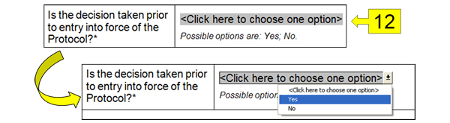

**Figure 53**

1. **Section to be filled depending on the answer provided**: Some sections of the Common Formats need to be filled only if you provide specific answer to the previous question. In the online registration forms additional fields will appear on the screen automatically (see section 4.1.3.4), in offline Common Formats such sections have a note “*Please fill this section only if…*”. Accordingly, you should fill the section only if you have selected the indicated answer, and if not, you should proceed to the next section, or to the section you are asked to go (e.g. you can be asked to “Go to section D”).

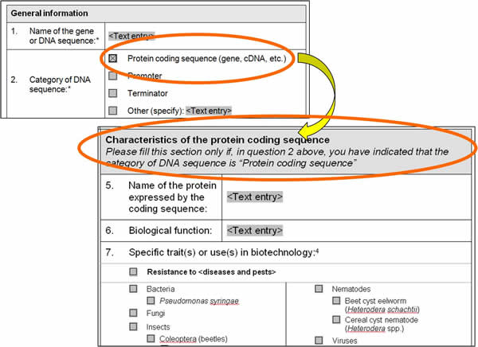

**Figure 54**

# Training Site

In order to familiarize yourself with the BCH, and particularly with its Management Centre, you are encouraged to visit the Training Site of the BCH. It is a mirror copy of the official BCH and has been implemented to help BCH users familiarize themselves with the functioning of the BCH Management Center without altering the content of the official portal. The Training Site is available through the “Resources” and “Help” sections of the BCH.

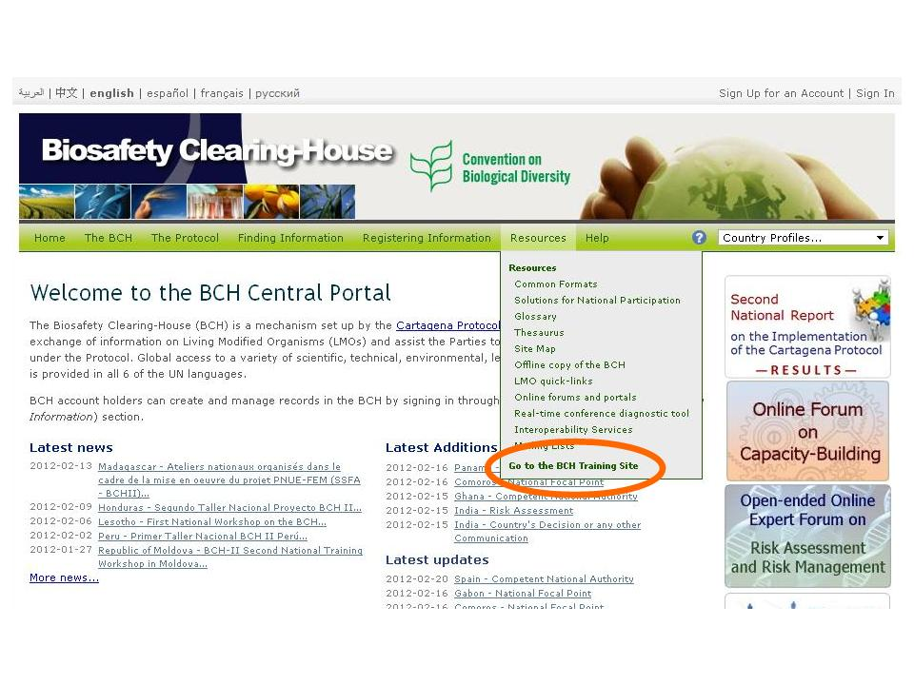

**Figure 55**

When you click on “Go to the BCH Training Site” link in the “Resources” or “Help” section, you will be directed to the “Sign-In” page. Once signed in (using your registered email address and password), you will proceed to the main page of the Training Site.

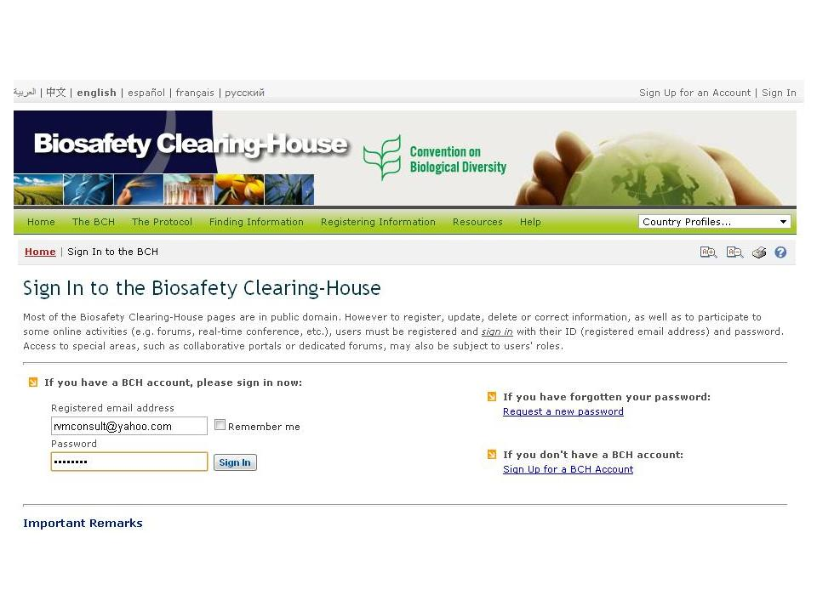

**Figure 56**

To practice registering information in the BCH you should first select the training database from a menu “Training Space” located at the right most part of the Training Site’s main page. By clicking the down arrow key, all the currently existing training instances will appear for your selection. Unless directed otherwise (e.g. during a dedicated workshop), please use the default value “Public BCH Training”, all other instances will require a password to continue.

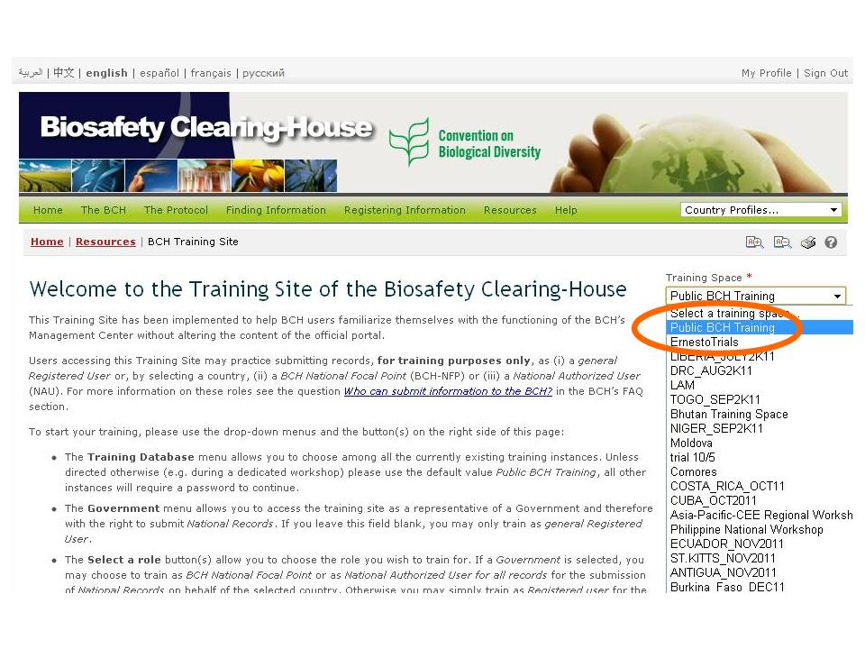

**Figure 57**

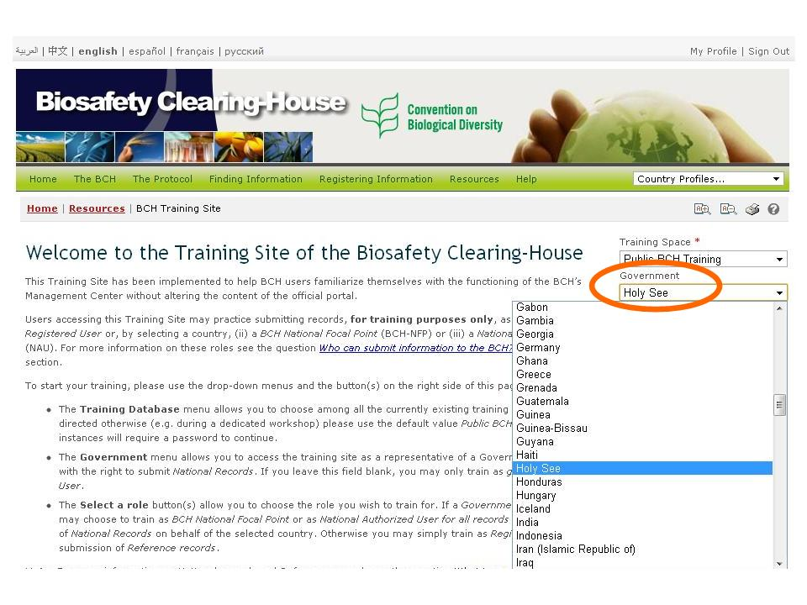With the “training space” already selected, click the down arrow key under the “Government” section and select the name of the country as indicated in the list. If you leave this field blank you may only train as a *general registered user* for submission of Reference records.

**Figure 58**

Once the “government” is selected, you can choose a role you wish to train for. If you are a designated BCH-NFP, you can select the “Training: BCH National Focal Point” role so you can practice with records validation.

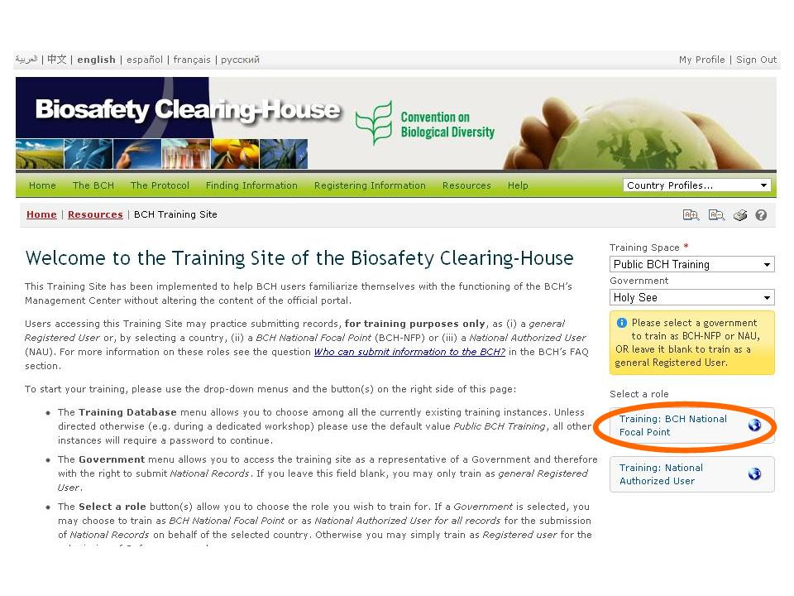

**Figure 59**

Upon selection of the role, you will be directed to the Management Centre of the Training Site of the BCH, where you can now start practicing its different functionalities under a training ID indicated at the right side of the page. By clicking on the appropriate link in the left-hand menu you can: (i) register a new record (or save it as a draft); (ii) edit a published record; (iii) edit a draft record; and or (iv) check the status of your records.

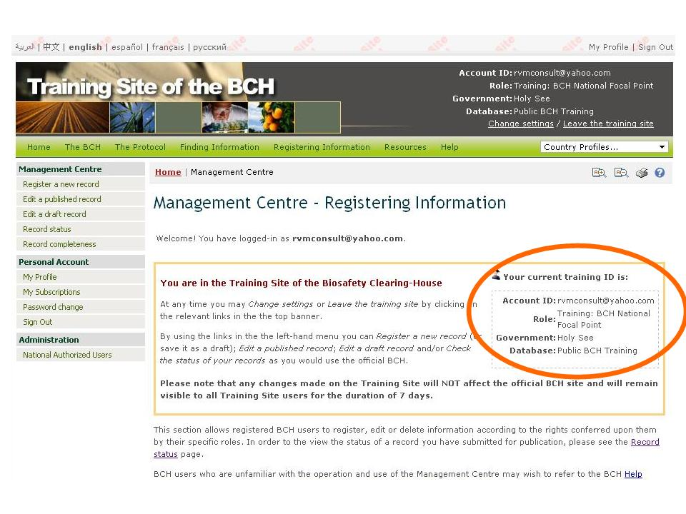

**Figure 60**

Should you wish to change your role (from NAU to NFP or vice versa), click the “Change setting” link located at the top most right of the page. You will note the changes with the training ID, indicating the new role.

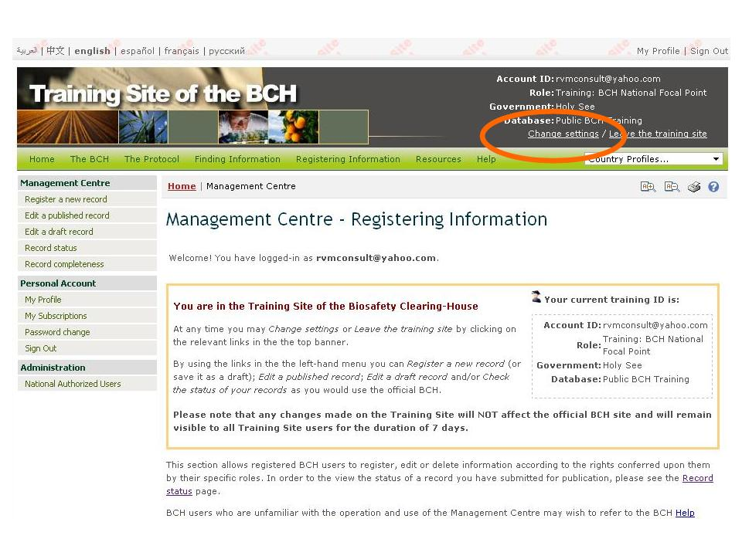

**Figure 61**

The information registered on the Training Site does not affect the official BCH site and is not made publicly available. However it remains visible to all Training Site users for the duration of 7 days.

When you finish your training session you can return to the official BCH site by clicking the “Leave the training site” link located at the top most right of the page.